**HOME WORK 23**

**ROSE KWENDE**

1. Watch the following video and learn how to install GUI and setup the NIC on a minimally installed server

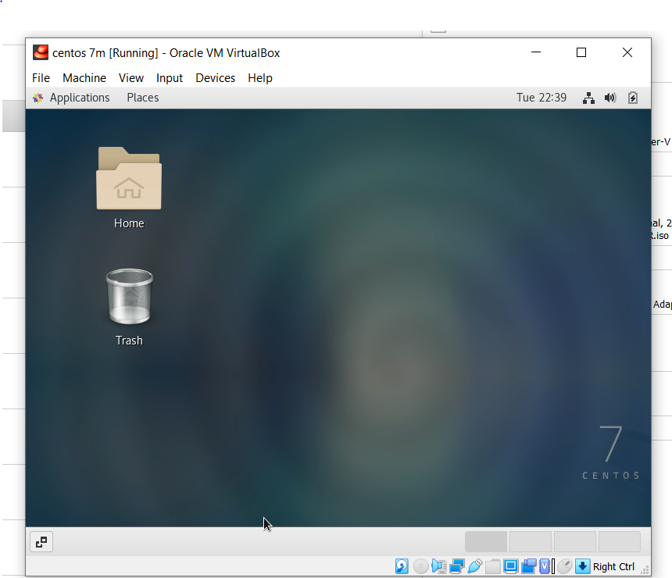

2. Watch the following video and setup your Kali Linux System for Cybersecurity Pen Testing.

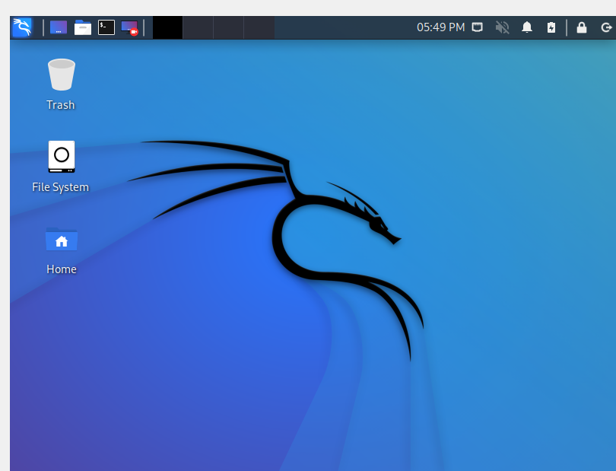

3. Watch the following video and setup your metasploitable in preparation of your cybersecurity class

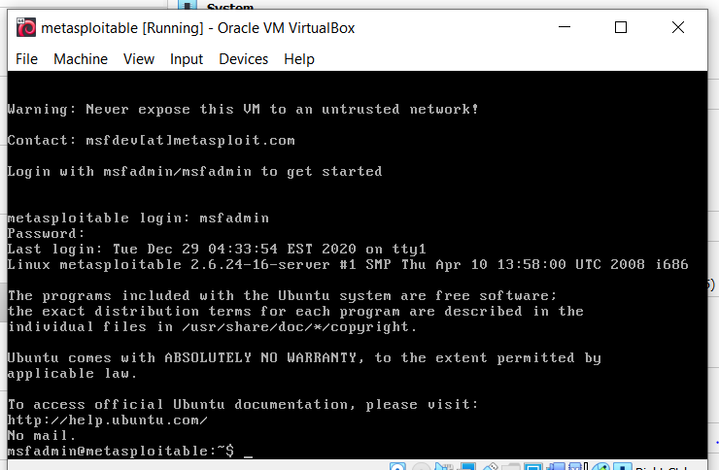

4. Learn how to Burn an ISO image to a thumb drive

